|  |  |
| --- | --- |
| CO mass | 0.5*MJ |
| CO velocity | 1 AU/day |
| Collision time | 3*TJ |

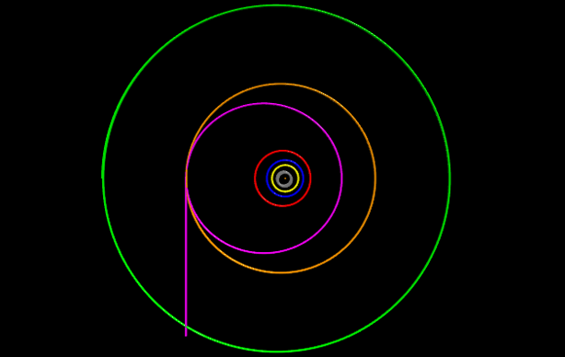

|  |  |
| --- | --- |
| CO mass | 0.75*MJ |
| CO velocity | 2 AU/day |
| Collision time | 3*TJ |

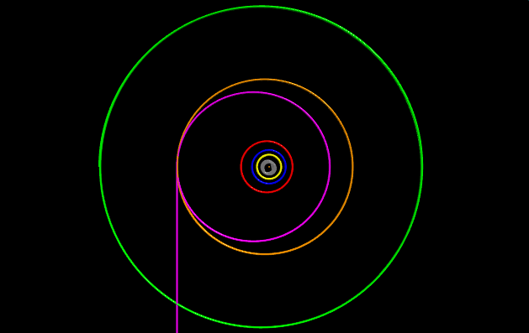

|  |  |
| --- | --- |
| CO mass | 4*MJ |
| CO velocity | 2 AU/day |
| Collision time | 3*TJ |

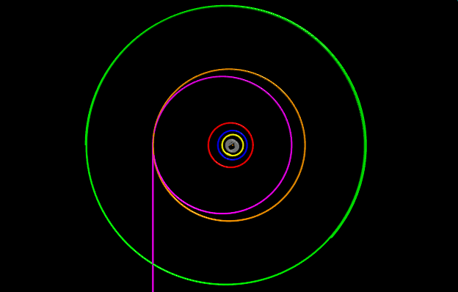

|  |  |
| --- | --- |
| CO mass | 4*MJ |
| CO velocity | 0.1 AU/day |
| Collision time | 3*TJ |

